# 🌐 My Personal Portfolio

Welcome to the source code of my personal developer portfolio! This project showcases my skills, experience, and work. It's built with modern web technologies and reflects who I am as a developer.

## 📁 Live Website

🔗 https://prachipathak1996.github.io/portfolio.web/

---

## 📸 Preview

---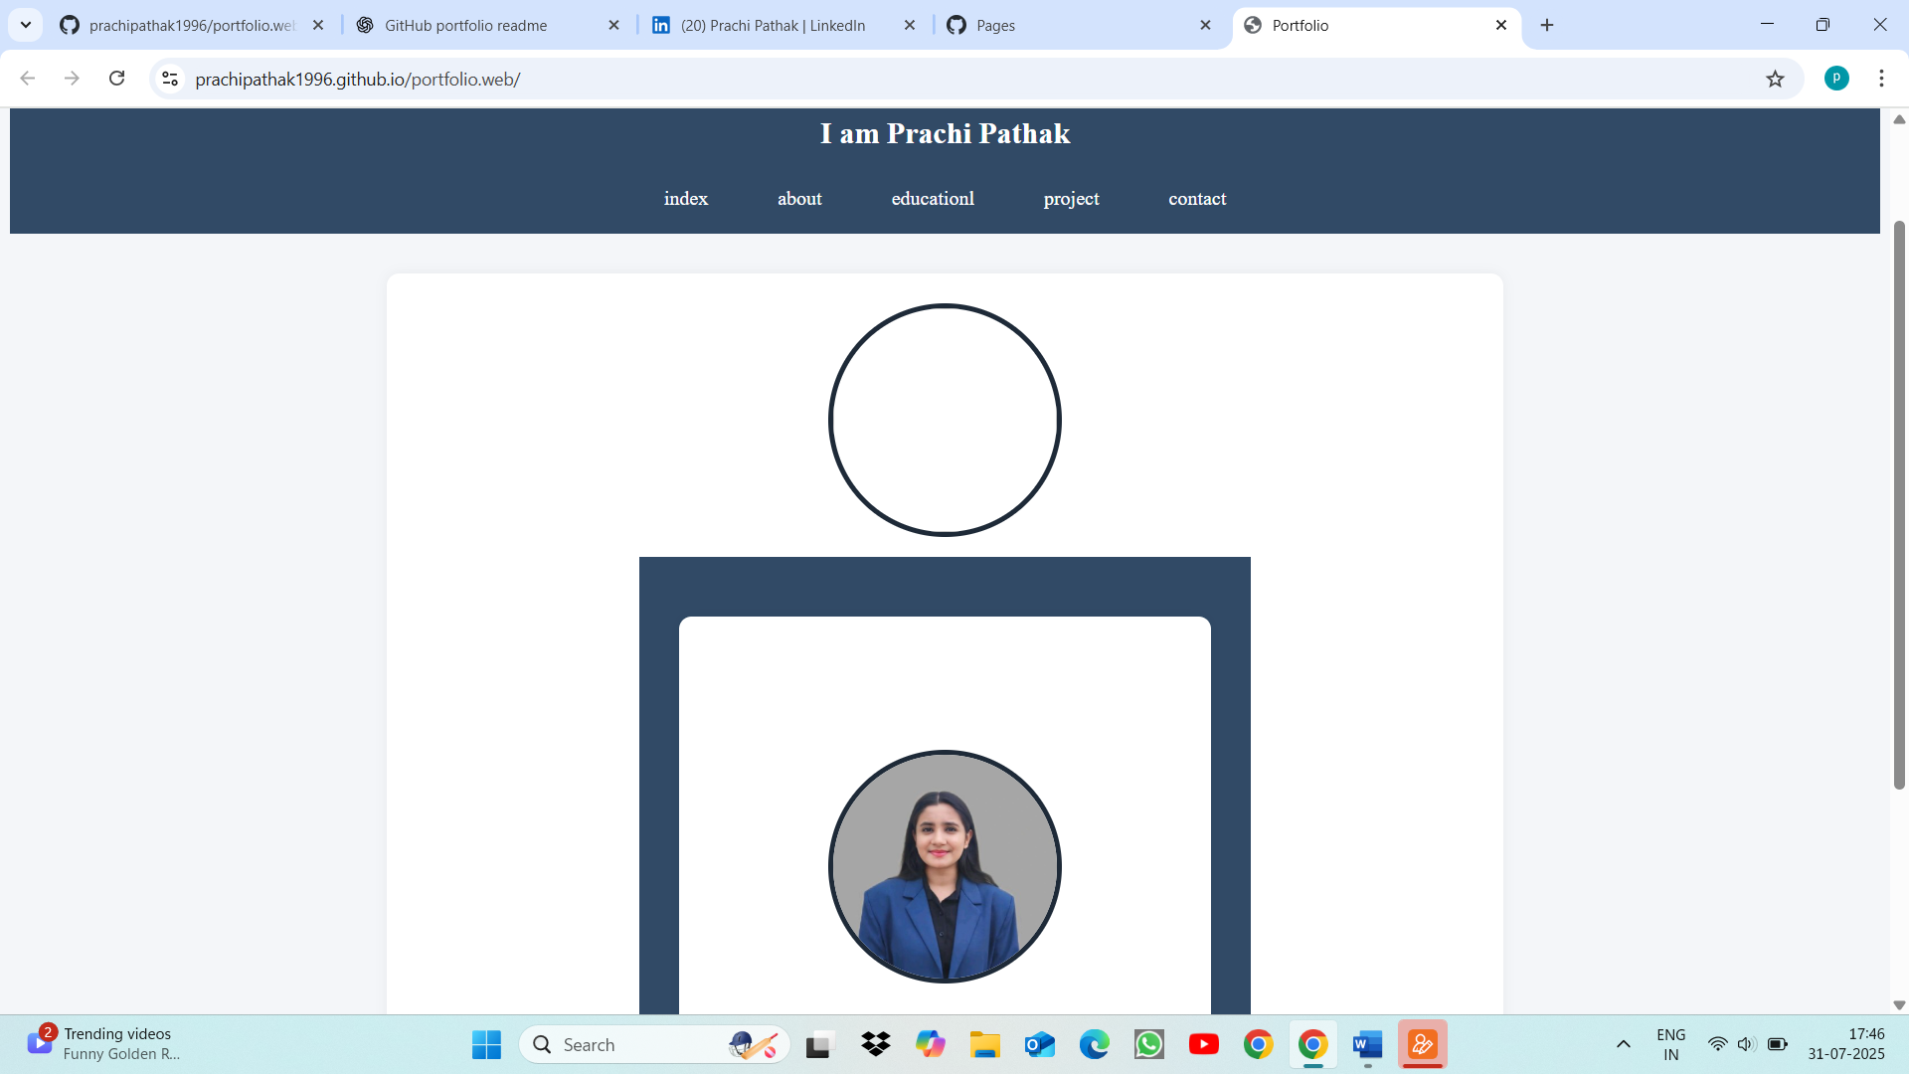

## 🔧 Built With

- HTML5 / CSS3 / JavaScript

---

## 🧠 Features

- Responsive design for all devices

- Project showcase with live previews

- Downloadable resume

- Contact form with email functionality

---

## 🛠️ Installation

Index-about-educationl-project-contact

📬 Contact

If you'd like to get in touch:

📧 Email: prachippathak010@gmail.com

💼 LinkedIn: www.linkedin.com/in/prachippathak

📄 License

This project is open-source and available under the MIT License.